Effects of decomposition, sampling depth, and body condition on biomarkers that reflect stressors in blubber tissue of stranded gray whales

Valentina Melica¹, Shannon Atkinson¹, Jessica Huggins², Matthew Rogers³, Bryan Cormack³, Debbie Duffield⁴, Dalin D'Alessandro⁴ and John Calambokidis²

¹ University of Alaska Fairbanks, College of Fisheries and Ocean Sciences, Fisheries Department, Juneau, USA.
² Cascadia Research Collective, Olympia, USA.
³Alaska Fisheries Science Center, NOAA; Juneau, USA
⁴Portland State University, Biology Department, Portland, USA

TO DISCUSS:
We are including the following variables:
- Cortisol, Corticosterone
- Aldosterone
- Lipid %
In relation to:
- Blubber depth (1, 2, 3)
- COD ( 1,2)
- Body condition (1,2,3)
- Age and sex (1,2, 3)

ABSTRACT
Gray whales (Eschrichtius robustus) from the Eastern North Pacific Ocean experienced an unusual mortality event between 2019 and 2023, with unexpected high numbers of stranded individuals. Blubber from stranded whales is used for a variety of analyses that can help elucidate the physiological well-being of the individual, including the investigation of endocrine biomarkers and lipid content. However, cause of death, sampling location and depth, as well as the body condition of the animal at the time of death can potentially affect the biochemistry of these compounds. The goal of this study was to investigate the variability in total lipid, cortisol, corticosterone, and aldosterone concentrations across the full blubber depth from 35 individual gray whales stranded in Washington and Alaska between 2010 and 2019. The state of carcass decomposition, nutritional condition age, sex, ad cause of death of the individual, were also accounted for. Full-depth blubber was subsampled at three different distances from the skin: Surface (0-2 cm), Middle (3-6 cm), Bottom (> 6). Indices of Good, Fair and Poor body conditions were assigned by field responders and recovered from stranding reports. Overall, cortisol and aldosterone concentrations, but not total lipids, were affected by sex and age class, with immature females having significantly higher concentrations. Concentrations of all three hormones and total lipid (as a percent of mass analysed) were higher in the surface layer, but the difference was significant only for cortisol (p =0.05) and total lipid (p<0.05). Cortisol and corticosterone concentrations showed similar trends among cause of death with individuals that perished due to trauma or nutritional stress having elevated concentrations. Aldosterone concentrations were lowest in individuals that perished due to trauma, and highest in individuals that died after a predation event. However, no statistical difference was detected for any of the three hormones. Body conditions appeared to affect each hormone differently, with no significant differences were detected, although total lipid content and corticosterone were correlated (r=0.4, P=?), suggesting this hormone may play an important role in lipid metabolism. ADD another sentence discussing the findings and what they may mean. These findings further our understanding of using bioindicators for metabolic well-being in health assessments of large whales.

Introduction
Gray whales occur exclusively in the Pacific Ocean (D. Rice et al., 1984) and two populations are recognized, Western (WNP) and Eastern North Pacific (ENP) populations, with overlapping feeding grounds in the eastern North Pacific (Mate et al., 2011) While the WNP population is still considered as critically endangered, the ENP population was removed from the U.S. endangered species list in 1994. Abundance estimates indicate the ENP population has reached carrying capacity at 20,000 – 22,000 individuals (Swartz, 2018) and the most up-to-date estimate is approximately 27,000 individuals (Durban et al., 2017). The majority of ENP gray whales migrate annually between the lagoons of the Baja Peninsula, their breeding grounds, and the continental shelves of the Bering, Chukchi, and more recently the Beaufort Seas, to feed. An exception is the Pacific Coast Feeding Group (PCFG), a small group that forage primarily between southeastern Alaska and Northern California (Calambokidis et al., 2012). Migration and reproduction are tightly connected, as the migrating groups are staggered in time based on sex and reproductive states (D. W. Rice & Wolman, 1971; Swartz, 2018).
Gray whales are considered ecosystem sentinels (Moore, 2008) due to their feeding ecology and migratory patterns which are likely affected by changes in prey composition driven by climate or oceanographic perturbations. As they forage on lower trophic levels, primarily on benthic amphipods and decapods, and are seasonally present in the Arctic, gray whale migration is affected by the Pacific Decadal Oscillation, El Niño-La Niña oscillations, and sea ice (Moore et al., 2003, 2007; Perryman & Lynn, 2002; Urbán et al., 2003). Along their migrating route, gray whales are exposed to a variety of anthropogenic sources of disturbance, such as contaminants (Gulland et al., 2005; Krahn et al., 2001; Tilbury et al., 2002), underwater noise (Moore & Clarke, 2002), fishing operations and ship collisions (Baird et al., 2002; Douglas et al., 2008). Studies from the late 1980s reported avoidance and change in behavior due to noise disturbance comparable to drilling operations and air guns arrays (Malme et al., 1988; Moore & Clarke, 2002). Furthermore, given their foraging habit, gray whales are likely to ingest and accumulate chemical contaminants: even if no toxic concentrations have been reported in stomach content and blubber tissue of this species (Hayes, 2018; Krahn et al., 2001; Varanasi et al., 1994), even at low quantities organic contaminants may act as endocrine-disrupting chemicals, external compounds that can alter normal hormone function (Fossi & Marsili, 2003). Long-term effects of endocrine disrupting chemicals include reproductive failure, poor body conditions and adrenal gland damage (Godard-Codding & Collier, 2018). In 1999 – 2000, the ENP population of gray whales experienced an Unusual Mortality Event with more than 600 carcasses reported, with starvation as a contributing factor to mortality (Gulland et al., 2005). In 2019, more than 200 animals were found stranded across Mexico, United States and Canada and NOAA has issued a second UME (NOAA, 2020). While no common cause of death has been identified, many carcasses were in poor body conditions.
The speed and intensity of climate and oceanographic changes in marine ecosystems and the increased wildlife-human interactions warrant the need to search for biomarkers for assessing the physiological well-being and possible stress responses. Prolonged exposure and stimulation of an endocrine response to any number of stressors may be detrimental to reproduction (Atkinson et al., 2015; Tilbrook et al., 2000; Wasser et al., 2017) and immune system function (Webster Marketon & Glaser, 2008), potentially leading to population decline (Wasser et al., 2017). Corticosteroids are involved in the physiological response to stress in terrestrial and aquatic mammals (Atkinson et al., 2015); however, there is a paucity of published research on physiological processes in large whales and specifically on stress-related endocrine profiles. Cortisol and corticosterone are secreted by the adrenal glands and are involved in maintaining metabolic homeostasis, including the stress response, with their main function being stimulation of gluconeogenesis to sustain the energetic requirements (Atkinson et al., 2015; Peckett et al., 2011; Tanaka et al., 2017). Aldosterone is another adrenal hormone and is primarily regulated by the rennin-angiotensin system. It mainly acts to regulate electrolyte balance, water retention and blood pressure (Kubzansky & Adler, 2010). When secreted excessively or over a prolonged period of time, these hormones can have detrimental effects on skeletal muscle and on the reproductive and cardiovascular systems.
Steroid hormones have been measured in a variety of tissues in multiple wildlife species. When available, blood serum, and feces are the matrices of choice for investigating endocrine response to very recent events (minutes to hours) (Atkinson et al., 2015; Burgess et al., 2017; Champagne et al., 2017; Rolland et al., 2005; Valenzuela-Molina et al., 2018), whereas for life-long endocrine profiles, steroid hormones have been extracted and measured in earplug and baleen plates (Hunt et al., 2014, 2017; Trumble et al., 2013). An increased number of studies have focused on blubber, as samples can be obtained with minimally invasive techniques and reflect close-to-recent physiological processes (Atkinson et al., 2020; Cates et al., 2019, 2020; Melica et al., 2021; Mingramm et al., 2020). Recent studies have shown that accumulation of steroids in this tissue occurs within hours from their secretion in blood (Champagne et al., 2017, 2018), suggesting that blubber can be used to describe recent physiological events.
Blubber is common to most marine mammals, and it consists of a vascularized layer of fat and connective tissue beneath the skin (Iverson & Koopman, 2019). Energy storage is the main function for this tissue; however, it also serves as a thermal insulator and aids buoyancy and hydrodynamics (Iverson & Koopman, 2019) . Being a dynamic tissue, blubber changes in response to reproductive status, nutritional status, and age. Analyses of lipid content and fatty acids are often investigated with stable isotopes as a tool to better understand foraging ecology and diet (REF). A few studies have also looked at lipid profiles in relation to health condition.
Steroid hormones are synthesized from cholesterol and because of their lipophilic nature, blubber is a ideal tissue for endocrine

The overall goal of the present study was to investigate corticosteroids and lipid content in blubber samples of stranded gray whales that had a variety of causes of death. Specific objectives included:
  - To evaluate corticosteroid hormone concentrations in relation to sex, age class, body conditions;

  - To compare hormone concentrations in stranded animals that perished of different causes of death;
  - To evaluate corticosteroid hormone concentration in relation to blubber depth and state of carcass decomposition.
The expected outcome will be to better understand how different life history traits and physiological parameters either influence or may be influenced by varying stressors. In doing so, the ability to predict the severity or duration of future unusual mortality events may influence the success of conservation measures.

Methods

Individual Samples
Blubber samples from 35 (22 females and 13 males) gray whale carcasses were obtained through the United States Marine Mammal Health and Stranding Response Program (MMHSRP). These samples came from whales that were found and examined between 2010 and 2019, along the coasts of Washington (n= 28) and Alaska (n=7). Out of 35 individuals, 19 were part of the 2019-2022 UME. Information on the animal (e.g., sex and length) as well as likely cause of death (COD), body condition and carcass condition were obtained from the MMHSRP Level A forms and necropsy reports. Age class was primarily determined by the measured length and categorized as immature (body length lower than XX; n= 14) and adult (length greater than XX, n= 19). Age class was not assigned to two individuals. The
initial report assigned each animal one out of 4 categories of body condition that ranged from Excellent to Good to Fair, to Poor; however, due to limited sample size the categories of Excellent and Good were combined. Similarly, carcass conditions were rated on a scale of 2 to 4, with 0.5 increments, where 2 indicated a fresh carcass, 3 was a carcass with moderate decomposition, and 4 was a highly decomposed carcass. The cause of death (COD) was determined as:
Trauma (n= 10), when signs of a blunt or traumatic impacts were present on the carcass, including collision with vessels;
Nutritional stress (n= 12), when the animal was found severely emaciated;
Entanglement (n= 2), when found entangled in fishing line (one of the animals was a live stranding);
Predation (n= 3), when the animal showed signs of attacks from killer whales (e.g. rake marks, bite makes) or was known to have been harvest. For 8 individuals, COD was not determined.

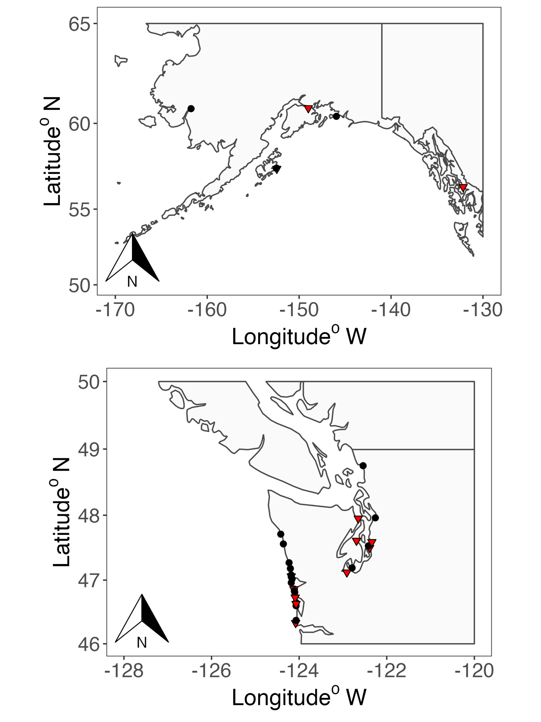
Figure : locations of whale strandind. Females are black dots, males are red triangles

Hormone extractions, validation and measurement
Full blubber depth samples were subsampled at their storage at three MMHSRP locations and transferred to the University of Alaska Fairbanks facility in Juneau AK, where they were stored at -80°C until further processing. Blubber depth ranged between 6 to 12 cm. Each sample was subsampled along three depth categories: “Surface” from skin to 2 cm depth, “medium” from 3 to 6 cm, and “bottom” from > 6 cm blubber depth. The mass of subsamples ranged between 0.096 and 1.270 g (mean ± standard deviation= 0.23 ± 0.18 g) for all whales. Hormone extraction was performed following the step-wise process described in (Atkinson et al., 2020; Melicai et al., 2021)adapted from (Kellar et al., 2006; Mansour et al., 2002). Briefly, samples were first macerated manually using a Teflon tip homogenizer in 1 ml of ethanol, then extracted using a series of solvent-supernatant transfers, with multiple organic solvents (ethanol, acetone, ether, acetonitrile and hexane). Extracts were diluted in 1 ml of methanol before being aliquoted for each assay, dried under forced air and rehydrated with assay buffer. Hormone concentrations were measured using enzyme immunoassay (EIA) from Arbor Assay (Ann Harbor, MI) for cortisol (Catalog number # K003), corticosterone (# K014) and aldosterone (# K052), following the manufacturer’s protocols. Analytical validation (parallelism and accuracy test) and biological validations for cortisol and corticosterone are reported in Melica et al. (2022), validation of aldosterone is presented below. For each sample, hormones measurements (in pg/ml) were corrected for dilution factor and extracted blubber mass, and expressed as ng/g. The intra-assay coefficient of variation (CV) was <10%, for all hormones. If any sample had a CV >10%, it was re-diluted accordingly and re-assayed. Inter-assay validation was determined using two internal controls for each hormone. For the corticosterone assay, the CVs (%) of the internal controls used were 16.9% and 10.9%; for cortisol, 12.2% and 15.6%; for aldosterone, 11.5% and 11.2%.

Validation of aldosterone EIA for gray whale blubber

Analytical validation for aldosterone was performed testing pools of extract from males (n=8) and females (n=8) for parallelism and accuracy. To test for parallelism, each pool was serially diluted (1:1, 1:2, 1:4, 1:8, 1:16 and 1:32) and tested for parallel displacement with the standard curve. This step is used to confirm that the assay antibody can reliably bind the antigen throughout the range of the standard curve. It also indicates at what dilution hormone concentration shows to 50% binding. Parallelism was assessed both visually and using a t-test to determine statistical differences in slopes, with lack of significance supporting parallelism. The accuracy test is used to determine if any other compounds in the extracts are interfering with the antigen-antibody binding of the assay, testing how well the measured concentrations corresponded to added concentrations of each hormone. For this step, an equal volume of each pool was spiked with each standard, the recovered mass was graphed against the added mass and it was tested for linearity. Linearity is met when a linear slope close to 1.0 (acceptable range: 0.7 – 1.3) is achieved (Hunt et al., 2017)

Lipid extraction and measurement
TBD

Statistical Analysis
All statistical and graphical analyses were conducted using the software R v.3.5.2 (R Core Team, 2021). Exploratory analysis to assess normality and homogeneity of variances was conducted on both the row data and residuals from fitted linear models.
When normality requirements were met, linear models and parametric tests (ANOVA, Student’s T-test, Tukey post-hoc) were applied. Otherwise, corresponding non-parametric options (Generalized linear model, Kruskal-Wallis and Wilcoxon tests) were chosen.

Age-class, sex and body condition
For the analysis of hormone concentrations and lipid content in relation to age class and sex, the dataset was filtered to include individuals of known age class and sex. Generalized linear models were fitted to cortisol, corticosterone, and aldosterone concentrations in relation to age class, sex and the interaction of both. The models were then compared among them and to the null model using the Akaike Index Criterion for small sample size (AICc). For all AICc analyses, the model with the lowest AICc was considered the best option. A post-hoc test comparing estimated marginalized means (EMM) was applied to determine if there was any statistical difference in hormones concentrations and lipid content. For the analysis of hormone concentrations and lipid content in relation to body condition
, only individuals with body conditions listed as GOOD, FAIR and POOR were compared. Outliers for corticosterone and aldosterone were also removed from the data.

Cause of death

Prior to analysis across the different COD, difference in hormone concentrations were tested between samples collected before and during the unusual mortality event declared in 2019. A series of Wilcoxon test showed that there was no significant difference in cortisol (p= 0.12), corticosterone (p= 0.34) concentrations between the two period. A significant difference was found for aldosterone (p= 0.01), driven by one sample collected in 2018 that measured high (>10 ng/g). When removed, the test still indicated a statistically significant difference (p =0.03) with mean concentrations being higher in samples collected in 2019.
Because hormone concentrations in relation to COD did not meet normality requirements (using Shapiro Wilk test on residuals), a non-parametric test for analysis of variance (Kruskall-Wallis) was used to test for significant differences.

Blubber depth and carcass condition
Analysis of hormone concentrations across blubber depth was accomplished with a
final datasets of 19 individuals for cortisol, of which 17 had values across all three blubber depths; 16 individuals for corticosterone with values of all blubber depths; 12 individuals for aldosterone, with 10 values across all three categories of blubber depth. Exploratory data analysis indicated that hormone concentrations did not meet the requirement for parametric test. Additionally, Pearson a correlation test indicated corticosterone to be positive correlated with cortisol (r = 0.49) and aldosterone (r= 0.65). To determine the effect of blubber depth on hormone concentrations and lipid content, generalized mixed effects models (function lmer in package lme4 CIT) were developed with blubber depth as fixed factors and whale ID as a random factor. The model was then compared to the null model using the Akaike Index Criterion for small sample size (AICc). A post-hoc test comparing EMM was applied to determine if there was any statistical difference in hormones concentrations and lipid content across blubber depth (emmeans).

.

Results
Validation of Aldosterone
Parallel displacement to the standard curve of the serial dilutions from the male and female blubber pools were confirmed visually and statistically for both sexes (p >0.05) (Table 3.2; Fig. 3.1C); for the accuracy check the standard mass recovered showed linear relationships with the mass added for both species and sexes, with slopes ranging from 1.0 to 1.3 (Table 3.2). The serial dilutions from the gray whale blubber showed 50% binding at 1:1 and 4:1, for females and males respectively.

Analysis of hormone concentrations and lipid content in relation to age class and sex

The model including the interaction of sex and age class as predictors was found as the best model to explain cortisol concentrations (AICc= 233.2), with immature females showing statistically different concentrations from adult males and adult females. Mean (± sd) cortisol concentrations were significantly elevated in immature females (17.30 ± 14.50 ng/g, n=8) compared to adult females (4.59 ± 3.63 ng/g, n=11; t(28)= -3.35, p= 0.01) and adult males (3.79 ± 3.51 ng/g, n=7; t(28)= 3.19, p= 0.02 whales. However, this difference was driven by the two outliers with concentrations higher than 30 ng/g, both measured in immature females. When those were removed, the model including age class, without sex, became the best model (AICc=187.1) and a weak difference was found in cortisol concentrations between immature and adult individuals (t(28)= -2.1, p= 0.05).
For corticosterone, the model with age class as explanatory variable was identified as the best model (AICc=182.3). Mean corticosterone was significantly higher in immature individuals (3.5 ± 5.6 ng/g, n=13) than in adults (1.3 ± 2.0 ng/g, n=19, Wilcoxon rank sum test : W = 64, p-value = 0.02). One immature female had concentrations > 20 ng/g. Once removed, the model including sex as explanatory variable was identified as the best model (AICc= 128.3). Mean corticosterone concentrations were not different between females (1.9 ± 2.0 ng/g, n=19) and males (1.0 ± 1.2 ng/g, n=12).
For aldosterone, the null model had the lowest AICc, followed by model including age class as explanatory variable (AICc= 156.3). Mean aldosterone concentrations were higher in adult whales (0.9 ± 3.3 ng/g, n=19) than immature (0.6 ± 0.7 ng/g, n=13; Wilcoxon rank sum W= 69, p= 0.04). This difference was driven by an adult female with aldosterone concentrations >10 ng/g. When the outlier was removed, the best model became the one including the interaction of age class and sex as explanatory variable (AICc= 39.2). Aldosterone concentrations were significantly different between immature and adult females (p= 0.01), and between immature females and immature and adult males (p= 0.03 and 0.01 respectively, Fig.XX). Age class was a predictor for lipid content, but the difference was not significant between immature and adult whales (p=0.2).
Age class was found as an explanatory variable for lipid content (AICc= 218.50), however the difference between adults (13.9 ±15.4 %) and immature (22.1±19.4%) was not statistically significant (p=0.25).
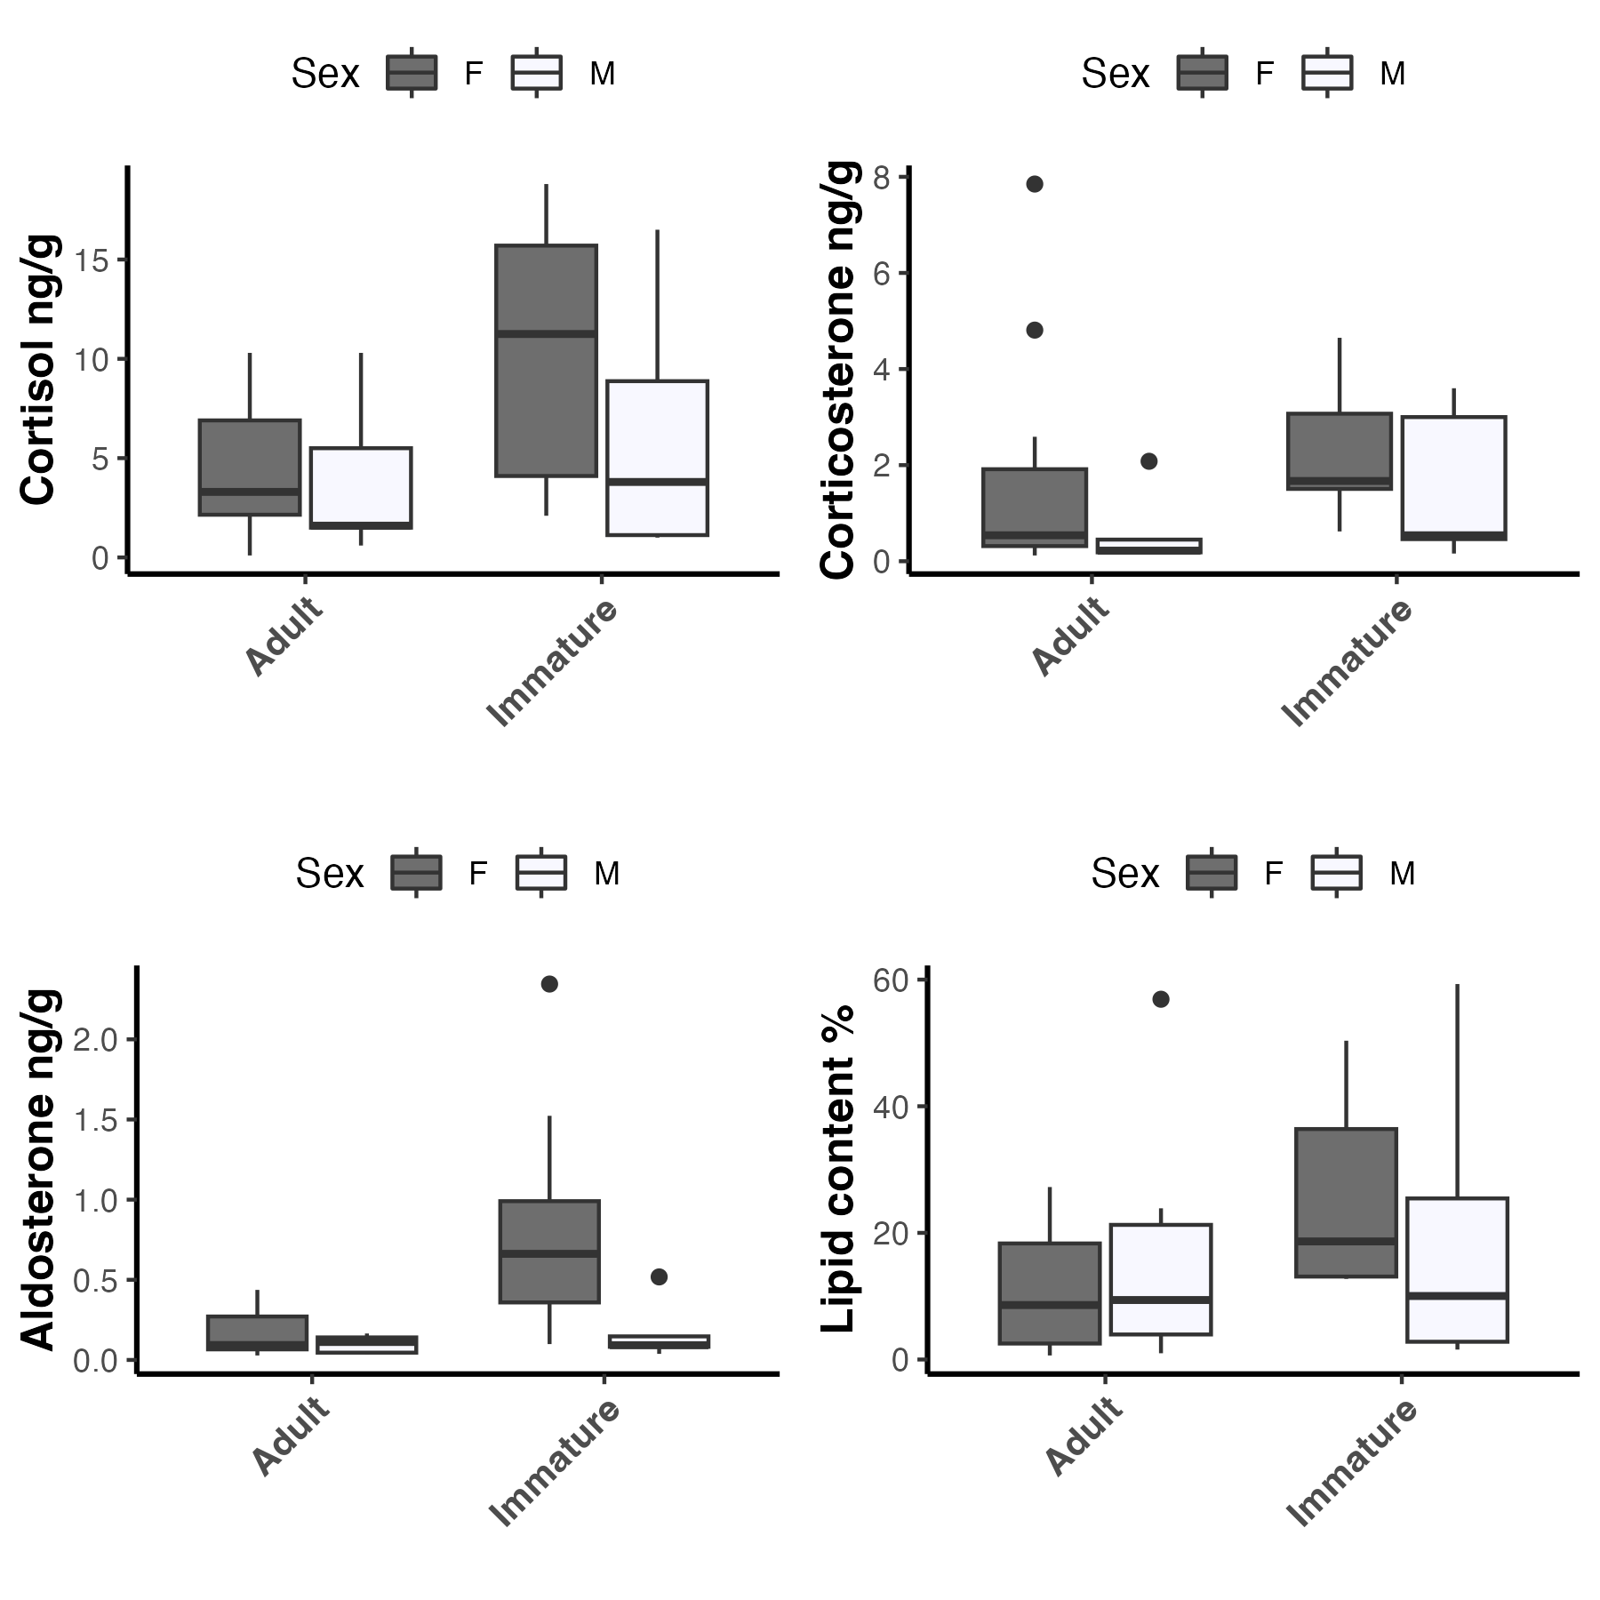

Figure XX: Hormone concentrations and lipid content in relation to age class with outliers removed. Cortisol concentrations were found elevated in immature individuals (p=0.05), whereas no significant difference was found in corticosterone concentrations. Aldosterone was significantly higher in immature females compared to immature males (p=0.03), adult males (p=0.007) and females (p=0.006). No significant difference was found in lipid content between immature and adult whales.

Analysis of hormone concentrations and lipid content in relation to body condition
Mean cortisol concentration was the lowest in samples from gray whales with fair body condition (mean ± sd = 3.79 ± 2.57 ng/g, n= 7), but it was not statistically significant from that from samples from whales that were in good c (13.0 ± 16.6 ng/g, n= 6 ) or poor (7.8 ± 8.7 ng/g, n= 16) condition (Kruskal-Wallis chi-squared = 0.7, df = 2, p-value = 0.7). Mean corticosterone concentration was elevated in samples from whales in poor body condition ( 2.11 ± 2.24 ng/g, n= 14), but it was not statistically significant from that from whales in good (0.8 ± 0.6 ng/g, n= 6 ) or fair (0.6 ± 0.7 ng/g, n= 7) condition (Kruskal-Wallis chi-squared = 0.9, df = 2, p-value = 0.6).
Mean aldosterone concentration was lowest in samples from whales in fair body condition (0.2 ± 0.09 ng/g, n= 7), but it was not statistically significant from that from whales in good (0.4 ± 0.3 ng/g, n= 6 ) or poor (0.4 ± 0.7 ng/g, n= 14) condition (Kruskal-Wallis chi-squared = 0.8, df = 2, p-value = 0.6, Fig 4). Lipid content was statistically different among body conditions (Kruskal-Wallis chi-squared = 8.2, df = 2, p-value = 0.02), with whales in good body conditions showing the highest, yet variable lipid content (FigXX).

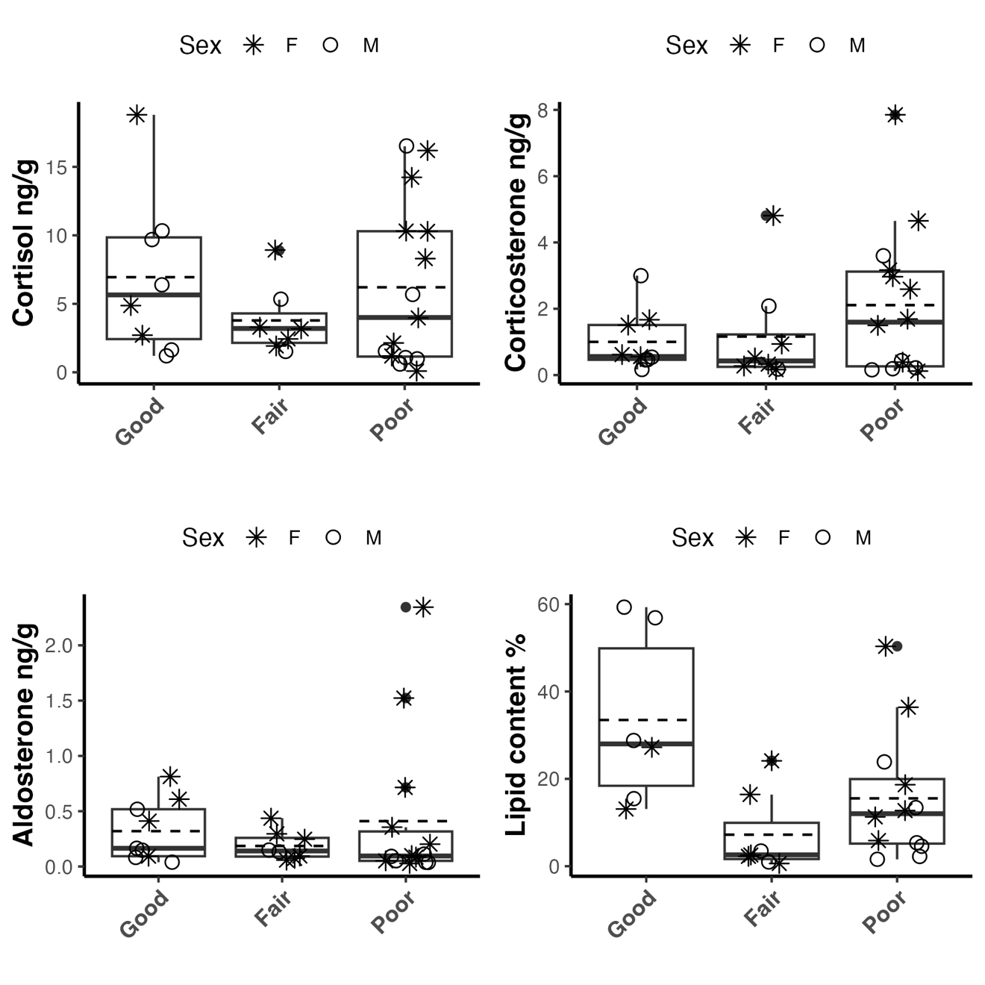
Figure 4: Hormone concentrations and lipid content in relation to body conditions. Hormone concentrations was not significantly different among adjusted body conditions with or without outliers. However lipid content was significantly higher in individuals in good body conditions compared to those in fair (p= 0.04)..

Analysis of hormone concentrations in relation to cause of death
Mean cortisol concentrations were 12.80 (±12.87) ng/g for samples in the trauma category, followed by 6.51 (±8.83) and 5.1 (±3.58) ng/g for samples in the nutritional stress and undetermined category and 3.8 (±3.68) and 1.7 (±1.00) ng/g for samples in the entanglement and predation categories (Fig. XX). However, the non-parametric ANOVA test perfumed found no significant difference (Kruskal- Wallis Chi-squared = 5.1, df = 4, p-value = 0.27). Analytical results did not change when two outliers, both with cortisol >30 ng/g, were removed.
Mean (± standard deviation) concentrations of corticosterone were 3.35 (± 6.96) ng/g for samples in the Trauma category, 2.76 (± 2.55) ng/g, 1.13 (± 1.40) ng/g for samples in the Undetermined and Nutritional stress, and 1.77 (± 1.74) and 0.29 (± 0.25) ng/g for samples in the Entanglement and Predation categories (Fig. XX). As for cortisol, the non-parametric ANOVA test indicated no significant difference (Kruskal- Wallis Chi-squared = 5.5, df = 4, p-value = 0.24). Results did not change when one sample with corticosterone >20 ng/g was removed.
Mean (± standard deviation) aldosterone concentrations were 2.23 (± 4.96) ng/g in samples from the Undetermined category, followed by 0.33 (± 0.26) and 0.29 (± 0.65) ng/g for samples in the entanglement and nutritional stress categories, and 0.27 (± 0.25), and 0.(± 0.39) ng/g for samples in the Entanglement and Predation categories (Fig. XX). However, there was no significant difference (Kruskal-Wallis: Chi-squared = 4.5, df = 4, p-value = 0.35). Similarly to the other two hormones, the results did not change when one obvious outlier (aldosterone > 10 ng/g )was removed from the analysis.

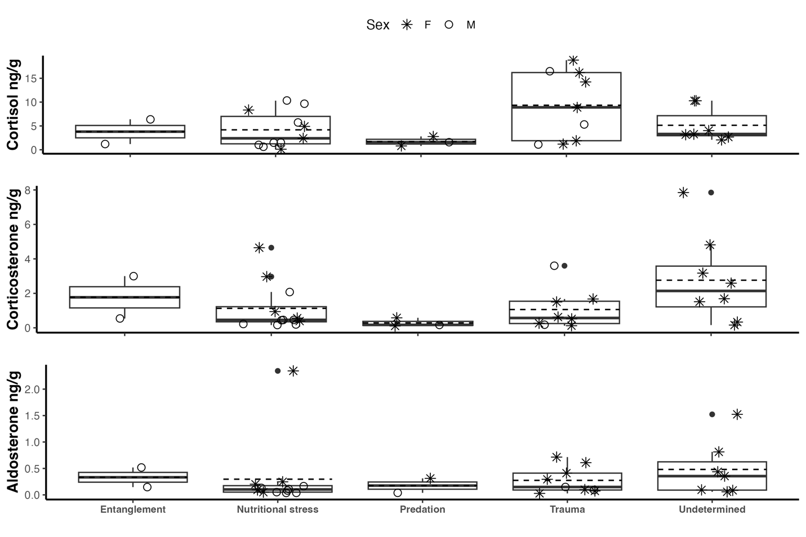

Figure XX: Hormone concentrations across cause of death. No significant difference was found in cortisol (a), corticosterone (b) and aldosterone (c) concentrations across the different cause of deaths.

Analysis of hormone concentrations across blubber depth and carcass conditions.
The means and standard deviations of all three corticosteroids were the greatest in the surface blubber layer for female gray whales, while the values were similar in all blubber depths for males (Table 1.) Based on AICc, the model for blubber depth as a predictor for hormone concentrations was better (AICc= 365.8) when compared to the null model for cortisol concentrations. The post-hoc test found significant difference in cortisol concentrations between the Surface and Medium blubber layers (EMM: t (34.2) = 2.5, p = 0.05). When three outliers (cortisol > 25 ng/g) were removed, the difference was no longer significant.
For corticosterone, the null model was had a lower AICc (116.7) when compared to the model with Blubber death as predictor (AICc=120.6). Similarly, the null model was the best model for aldosterone concentrations (AICc= 17.5) when compared to the model with blubber depth (AICc=25.2). Results did not change when one samples with concentrations higher than 1.00 ng/g was removed.
For lipid content, the model with blubber depth was found to be the best model (AICc= 278.3). Based on the post hoc test results the lipid content in the surface layer was significantly different from those in the medium (EMM t(19.1) = 3.4 , p= 0.01) and bottom (t(19.8) = 3.3, p= 0.01) layers. Two samples were identified as outliers as both had lipid content > 50%. When removed, the lipid content in the surface was significantly different from that in the medium layer (t(18.2)= 2.8, p= 0.03), but not the bottom layer.

Table 1: hormone concentrations and lipid content across blubber depth.
 |  | Cortisol ng/g |  |  | Corticosterone ng/g |  |  | Aldosterone ng/g |  |  | Lipid content %
Blubber Depth | Sex | mean | standard deviation | range | mean | standard deviation | range | mean | standard deviation | range | mean | standard deviation | range
Surface | F | 11.33 | 14.24 | 0.11-43.91 | 1.48 | 1.20 | 0.16-3.17 | 0.34 | 0.53 | 0.05-1.52 | 14.53 | 11.01 | 2.29-36.4
Medium | F | 4.83 | 6.22 | 0.12-16.95 | 0.76 | 0.47 | 0.28-1.52 | 0.05 | 0.03 | 0.02-0.11 | 0.93 | 0.66 | 0.12-1.6
Bottom | F | 8.58 | 9.11 | 0.17-27.8 | 0.71 | 0.62 | 0.07-1.75 | 0.05 | 0.04 | 0.02-0.12 | 0.24 | 0.27 | 0.03-0.7
Surface | M | 3.89 | 4.06 | 0.58-10.33 | 0.56 | 0.63 | 0.16-2.08 | 0.07 | 0.04 | 0.04-0.13 | 23.63 | 24.83 | 0.99-59.3
Medium | M | 2.95 | 3.58 | 0.52-10.96 | 0.79 | 0.69 | 0.15-1.87 | 0.07 | 0.11 | 0.01-0.26 | 3.65 | 3.19 | 0.53-8.29
Bottom | M | 3.06 | 3.70 | 0.42-10.87 | 0.59 | 0.37 | 0.13-1.16 | 0.15 | 0.24 | 0.003-0.43 | 12.81 | 16.08 | 0.28-34.3

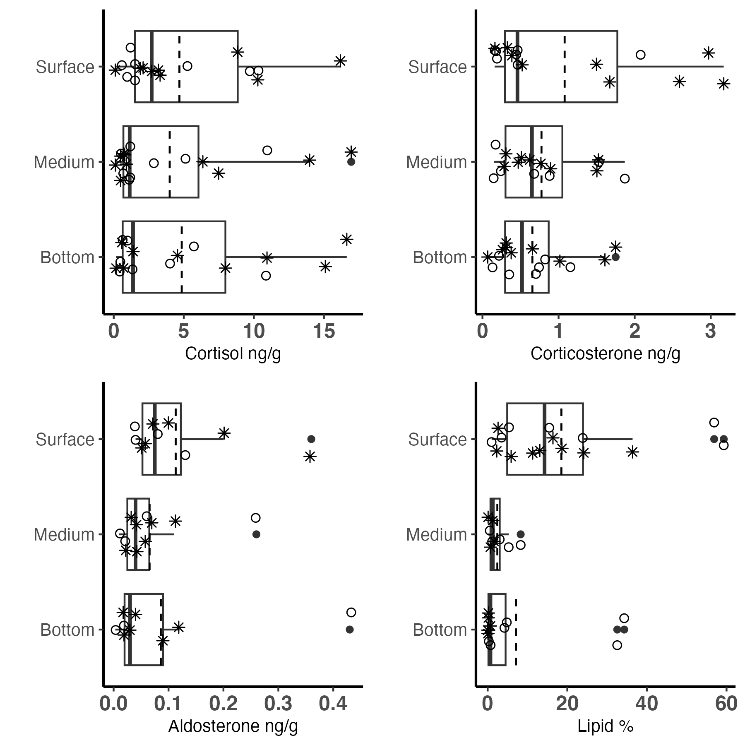
Figure : Hormone concentrations(ng/g) and lipid content (%) across blubber depth in samples from stranded female (*) and male (°) gray whales.

References:
Atkinson, S., Crocker, D., Houser, D., & Mashburn, K. (2015). Stress physiology in marine mammals: how well do they fit the terrestrial model? Journal of Comparative Physiology B, 185(5), 463–486. https://doi.org/10.1007/s00360-015-0901-0
Atkinson, S., Gendron, D., Branch, T. A., Mashburn, K. L., Melica, V., Enriquez‐Paredes, L. E., & Brownell, R. L. (2020). Pregnancy rate and biomarker validations from the blubber of eastern North Pacific blue whales. Marine Mammal Science, 36(1), 6–28. https://doi.org/10.1111/mms.12616
Baird, R. W., Stacey, P. J., Duffus, D. A., & Langelier, K. M. (2002). An evaluation of gray whale (Eschrichtius robustus) mortality incidental to fishing operations in British Columbia, Canada. J. Cetacean Res. Manage, 4(3), 289–296.
Burgess, E. A., Hunt, K. E., Kraus, S. D., & Rolland, R. M. (2017). Adrenal responses of large whales: Integrating fecal aldosterone as a complementary biomarker to glucocorticoids. General and Comparative Endocrinology, 252(July), 103–110. https://doi.org/10.1016/j.ygcen.2017.07.026
Calambokidis, J., Laake, J. L., & Klimek, A. (2012). Updated analysis of abundance and population structure of seasonal gray whales in the Pacific Northwest , 1998-2010 (Issue Paper SC/M12/AWMP2-Rev submitted to the International Whaling Commission Scientific Committee).
Cates, K. A., Atkinson, S., Gabriele, C. M., Pack, A. A., Straley, J. M., & Yin, S. (2019). Testosterone trends within and across seasons in male humpback whales (Megaptera novaeangliae) from Hawaii and Alaska. General and Comparative Endocrinology, 279(March), 164–173. https://doi.org/10.1016/j.ygcen.2019.03.013
Cates, K. A., Atkinson, S., Pack, A. A., Straley, J. M., Gabriele, C. M., & Yin, S. (2020). Corticosterone in central North Pacific male humpback whales (Megaptera novaeangliae): Pairing sighting histories with endocrine markers to assess stress. General and Comparative Endocrinology, 296(April), 113540. https://doi.org/10.1016/j.ygcen.2020.113540
Champagne, C. D., Kellar, N. M., Crocker, D. E., Wasser, S. K., Booth, R. K., Trego, M. L., & Houser, D. S. (2017). Blubber cortisol qualitatively reflects circulating cortisol concentrations in bottlenose dolphins. Marine Mammal Science, 33(1), 134–153. https://doi.org/10.1111/mms.12352
Champagne, C. D., Kellar, N. M., Trego, M. L., Delehanty, B., Boonstra, R., Wasser, S. K., Booth, R. K., Crocker, D. E., & Houser, D. S. (2018). Comprehensive endocrine response to acute stress in the bottlenose dolphin from serum, blubber, and feces. General and Comparative Endocrinology, 266(May), 178–193. https://doi.org/10.1016/j.ygcen.2018.05.015
Douglas, A. B., Calambokidis, J., Raverty, S., Jeffries, S. J., Lambourn, D. M., & Norman, S. A. (2008). Incidence of ship strikes of large whales in Washington State. Journal of the Marine Biological Association of the United Kingdom, 88(06), 1121–1132. https://doi.org/10.1017/S0025315408000295
Durban, J. W., Weller, D. W., & Perryman, W. L. (2017). Gray whale abundance estimates from shore-based counts off California in 2014/15 and 2015/16. Paper SC/A17/GW/06 Presented to Sci. Comm. Int. Whal. Comm.
Fossi, M. C., & Marsili, L. (2003). Effects of endocrine disruptors in aquatic mammals. Pure and Applied Chemistry, 75(11–12). https://doi.org/10.1351/pac200375112235
Godard-Codding, C. A. J., & Collier, T. K. (2018). The Effects of Oil Exposure on Cetaceans. In M. C. Fossi & C. B. T.-M. M. E. Panti (Eds.), Marine Mammal Ecotoxicology (pp. 75–93). Elsevier. https://doi.org/10.1016/B978-0-12-812144-3.00003-6
Gulland, F., Pérez-Cortés, H., Urbán, J. R., Rojas-Bracho, L., Ylitalo, G., Weir, J., Norman, S., Muto, M., Rugh, D., Kreuder, C., & Rowles, T. (2005). Eastern North Pacific gray whale (Eschrichtius robustus) unusual mortality event, 1999-2000. U.S. Department of Commerce. NOAA Technical Memorandum. NMFS-AFSC-150., March, 33 pp. http://www.afsc.noaa.gov/publications/AFSC-TM/NOAA-TM-AFSC-150.pdf
Hayes, K. R. R. (2018). Influence of life history parameters on patterns of persistent organic pollutants in cetaceans with an emphasis on the gray whale (Eschrichtius robustus) [Texas Tech University]. http://hdl.handle.net/2346/74500
Hunt, K. E., Lysiak, N. S., Robbins, J., Moore, M. J., Seton, R. E., Torres, L., & Buck, C. L. (2017). Multiple steroid and thyroid hormones detected in baleen from eight whale species. Conservation Physiology, 5(1), 1–14. https://doi.org/10.1093/conphys/cox061
Hunt, K. E., Stimmelmayr, R., George, C., Hanns, C., Suydam, R., Brower, H., & Rolland, R. M. (2014). Baleen hormones: a novel tool for retrospective assessment of stress and reproduction in bowhead whales (Balaena mysticetus). Conservation Physiology, 2(1), cou030–cou030. https://doi.org/10.1093/conphys/cou030
Iverson, S. J., & Koopman, H. N. (2019). Blubber. In B. Wursig, J. G. M. Thewissen, & K. M. Kovacs (Eds.), Encyclopedia of Marine Mammals (Third Edition) (Third edit, pp. 107–110). Academic Press. https://www.elsevier.com/books/encyclopedia-of-marine-mammals/wursig/978-0-12-804327-1
Kellar, N. M., Trego, M. L., Marks, C. I., & Dizon, A. E. (2006). Determining pregnancy from blubber in three species of delphinids. Marine Mammal Science, 22(January), 1–16. https://doi.org/10.1111/j.1748-7692.2006.00001.x
Krahn, M. M., Ylitalo, G. M., Burrows, D. G., Calambokidis, J., Moore, S. E., Gearin, P., Plesha, P. D., Jr, R. L. B., Blokhin, S. A., Tilbury, K. L., & Stein, J. E. (2001). Organochlorine contaminant concentrations and lipid profiles in eastern North Pacific gray whales (Eschrichtius robustus). Journal of Cetacean Research and Management, 3(1), 19–29.
Kubzansky, L. D., & Adler, G. K. (2010). Aldosterone: A forgotten mediator of the relationship between psychological stress and heart disease. Neuroscience and Biobehavioral Reviews, 34(1), 80–86. https://doi.org/10.1016/j.neubiorev.2009.07.005
Malme, C. I., Wursig, B., Bird, J. E., & Tyack, P. L. (1988). Observations of feeding gray whale responses to controlled industrial noise exposure. Proceedings of the Ninth International Conference on Port and Ocean Engineering under Arctic Conditions, 11, 55–74. https://doi.org/10.1016/0029-8018(87)90076-X
Mansour, A. A. H., Mkay, D. W., Lien, J., Orr, J. C., Banoub, J. H., ØIen, N., & Stenson, G. (2002). Determination of pregnancy status from blubber samples in minke whales (Balaenoptera acutorostrata). Marine Mammal Science, 18(January), 112–120. https://doi.org/10.1111/j.1748-7692.2002.tb01022.x
Mate, B., Bradford, A., & Tsidulko, G. (2011). Late-feeding season movements of a western North Pacific gray whale off Sakhalin Island, Russia and subsequent migration into the Eastern North Pacific. Paper SC/63/BRG23 Presented to the Scientific Committee of the International Whaling Commission, 1–7. http://archive.iwcoffice.org/_documents/sci_com/SC63docs/SC-63-BRG23.pdf%5Cnpapers2://publication/uuid/43C1FB70-1DB8-47CD-838C-1C2A5140BE5A
Melicai, V., Atkinson, S., Calambokidis, J., Lang, A., Scordino, J., & Mueter, F. (2021). Application of endocrine biomarkers to update information on reproductive physiology in gray whale (Eschrichtius robustus). PLoS ONE, 16(8 August). https://doi.org/10.1371/journal.pone.0255368
Mingramm, F. M. J., Keeley, T., Whitworth, D. J., & Dunlop, R. A. (2020). Blubber cortisol levels in humpback whales (Megaptera novaeangliae): A measure of physiological stress without effects from sampling. General and Comparative Endocrinology, 291(August 2019), 113436. https://doi.org/10.1016/j.ygcen.2020.113436
Moore, S. E. (2008). Marine mammals as ecosystem sentinels. Journal of Mammalogy, 89(3), 534–540. https://doi.org/10.1644/07-MAMM-S-312R1.1
Moore, S. E., & Clarke, J. T. (2002). Potential impact of offshore human activities on gray whales(Eschrichtius robustus. Journal of Cetacean Research and Management, 4(1), 19–25.
Moore, S. E., Grebmeier, J. M., & Davies, J. R. (2003). Gray whale distribution relative to forage habitat in the northern Bering Sea: current conditions and retrospective summary. Canadian Journal of Zoology, 81(4), 734–742. https://doi.org/10.1139/z03-043
Moore, S. E., Wynne, K. M., Kinney, J. C., & Grebmeier, J. M. (2007). Gray whale occurrence and forage southeast of Kodiak, Island, Alaska. Marine Mammal Science, 23(2), 419–428. https://doi.org/10.1111/j.1748-7692.2007.00102.x
NOAA. (2020). 2019-2020 Gray Whale Unusual Mortality Event along the West Coast. https://www.fisheries.noaa.gov/national/marine-life-distress/2019-gray-whale-unusual-mortality-event-along-west-coast%0D%0A%0D%0A
Peckett, A. J., Wright, D. C., & Riddell, M. C. (2011). The effects of glucocorticoids on adipose tissue lipid metabolism. Metabolism: Clinical and Experimental, 60(11), 1500–1510. https://doi.org/10.1016/j.metabol.2011.06.012
Perryman, W. L., & Lynn, M. S. (2002). Evaluation of nutritive condition and reproductive status of migrating gray whales (Eschrichtius robustus) based on analysis of photogrammetric data. Journal of Cetacean Research and Management, 4(2), 155–164.
R Core Team. (2021). R: A Language and Environment for Statistical Computing. In R. D. C. Team (Ed.), R Foundation for Statistical Computing. R Foundation for Statistical Computing. https://doi.org/10.1007/978-3-540-74686-7
Rice, D. W., & Wolman, A. A. (1971). The life history and ecology of the gray whale (Eschrichtius robustus). American society of mammalogists. https://doi.org/https://doi.org/10.5962/bhl.title.39537
Rice, D., Wolman, A., & Braham, H. (1984). The gray whale, Eschrichtius robustus. Marine Fisheries Review, 46(4), 7–14.
Rolland, R. M., Hunt, K. E., Kraus, S. D., & Wasser, S. K. (2005). Assessing reproductive status of right whales (Eubalaena glacialis) using fecal hormone metabolites. General and Comparative Endocrinology, 142(3), 308–317. https://doi.org/10.1016/j.ygcen.2005.02.002
Swartz, S. L. (2018). Gray Whale. In B. Würsig, J. G. M. Thewissen, & K. M. Kovacs (Eds.), Encyclopedia of Marine Mammals (Third Edit, pp. 422–428). Elsevier. https://doi.org/10.1016/B978-0-12-804327-1.00140-0
Tanaka, H., Shimizu, N., & Yoshikawa, N. (2017). Role of skeletal muscle glucocorticoid receptor in systemic energy homeostasis. Experimental Cell Research, 360(1), 24–26. https://doi.org/10.1016/j.yexcr.2017.03.049
Tilbrook, a J., Turner, a I., & Clarke, I. J. (2000). Effects of stress on reproduction in non-rodent mammals: the role of glucocorticoids and sex differences. Reviews of Reproduction, 5(2), 105–113. https://doi.org/10.1530/ror.0.0050105
Tilbury, K. L., Stein, J. E., Krone, C. A., Brownell, R. L., Blokhin, S. A., Bolton, J. L., & Ernest, D. W. (2002). Chemical contaminants in juvenile gray whales (Eschrichtius robustus) from a subsistence harvest in Arctic feeding grounds. Chemosphere, 47(6), 555–665.
Trumble, S. J., Robinson, E. M., Berman-Kowalewski, M., Potter, C. W., & Usenko, S. (2013). Blue whale earplug reveals lifetime contaminant exposure and hormone profiles. Proceedings of the National Academy of Sciences of the United States of America, 110(42), 16922–16926. https://doi.org/10.1073/pnas.1311418110
Urbán, J., Gallardo, A. G., & Ludwig, S. (2003). Abundance and mortality of gray whales at Laguna San Ignacio, México, during the 1997-98 El Niño and the 1998-99 La Niña. Geofisica Internacional, 42(3), 439–446.
Valenzuela-Molina, M., Atkinson, S., Mashburn, K., Gendron, D., & Brownell, R. L. (2018). Fecal steroid hormones reveal reproductive state in female blue whales sampled in the Gulf of California, Mexico. General and Comparative Endocrinology, 261, 127–135. https://doi.org/10.1016/j.ygcen.2018.02.015
Varanasi, U., Stein, J. E., Tilbury, K. L., Meador, J. P., Sloan, C. A., Clark, R. C., & Chan, S. L. (1994). Chemical contaminants in gray whales (Eschrichtius robustus) stranded along the west coast of North America. Science of the Total Environment, The, 145(1–2), 29–53. https://doi.org/10.1016/0048-9697(94)90296-8
Wasser, S. K., Lundin, J. I., Ayres, K., Seely, E., Giles, D., Balcomb, K., Hempelmann, J., Parsons, K., & Booth, R. (2017). Population growth is limited by nutritional impacts on pregnancy success in endangered Southern Resident killer whales (Orcinus orca). PLoS ONE, 12(6). https://doi.org/10.1371/journal.pone.0179824
Webster Marketon, J. I., & Glaser, R. (2008). Stress hormones and immune function. Cellular Immunology, 252(1–2), 16–26. https://doi.org/10.1016/j.cellimm.2007.09.006

